You need install Qt5.12.3 and Vs 2017 64. If you don’t know how to install qt, you can reference another word document (How to install Qt.docx).

If you installed Qt5.12.3 and Vs 2017 64; you need a addon qt-vsaddin-msvc2017-2.3.0.vsix, you can download it at <http://download.qt.io/archive/vsaddin/2.3.2/>.

Double click qt-vsaddin-msvc2017-2.3.0.vsix install it. Then open vs 2017 select [Qt VS Tool] and click [Qt Options].

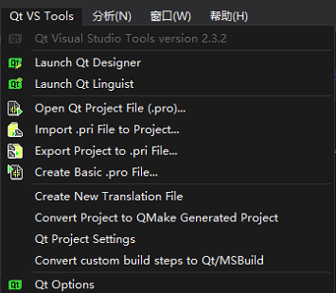

Then you will see this dialog window; Click [Add] to add Qt path.

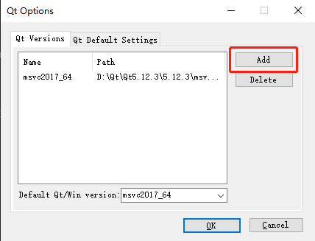

Input the Qt path where you installed with msvc2017_64.

